**HOMEWORK – 8 (Opendaylight)**

**TEAM - THE ORIGINALS**

Team Members: Tejas Madappa

Chandra Mohan

Vedant Bhoj

Ketan Rudrurkar

Hao Ran Chen

**Initializing dCloud Session:**

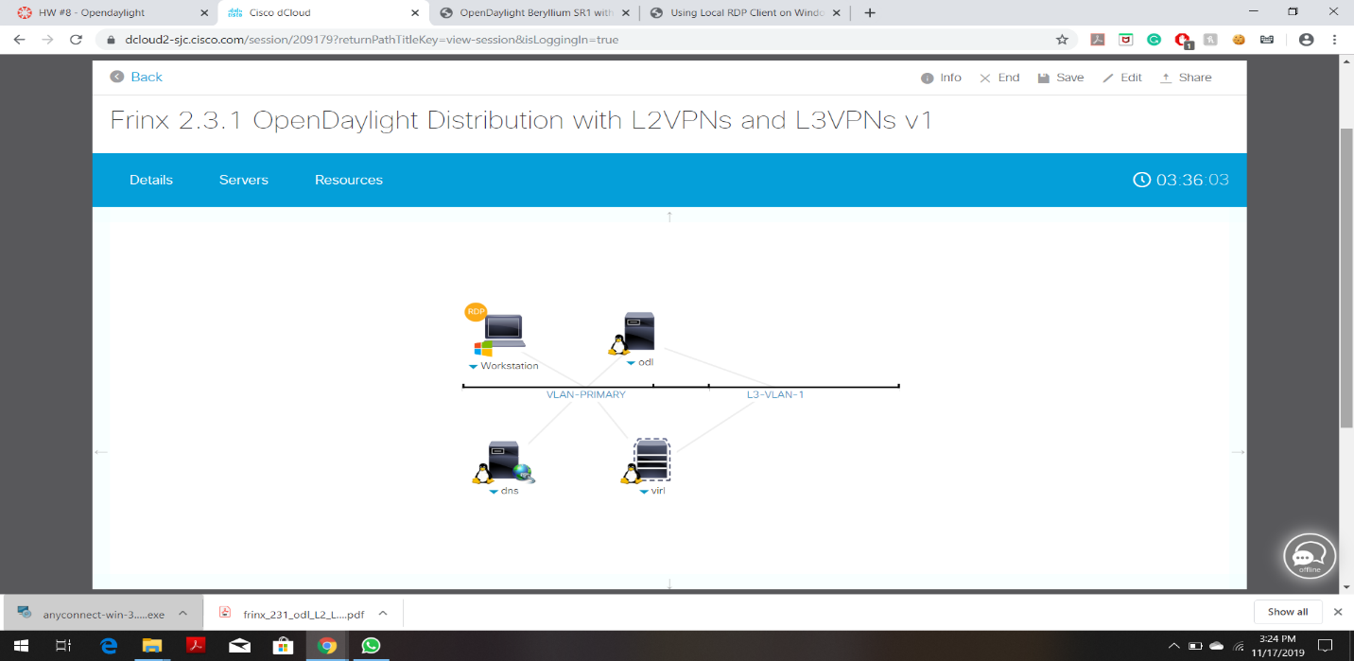

**Cisco AnyConnect VPN Connected to the dCloud:**

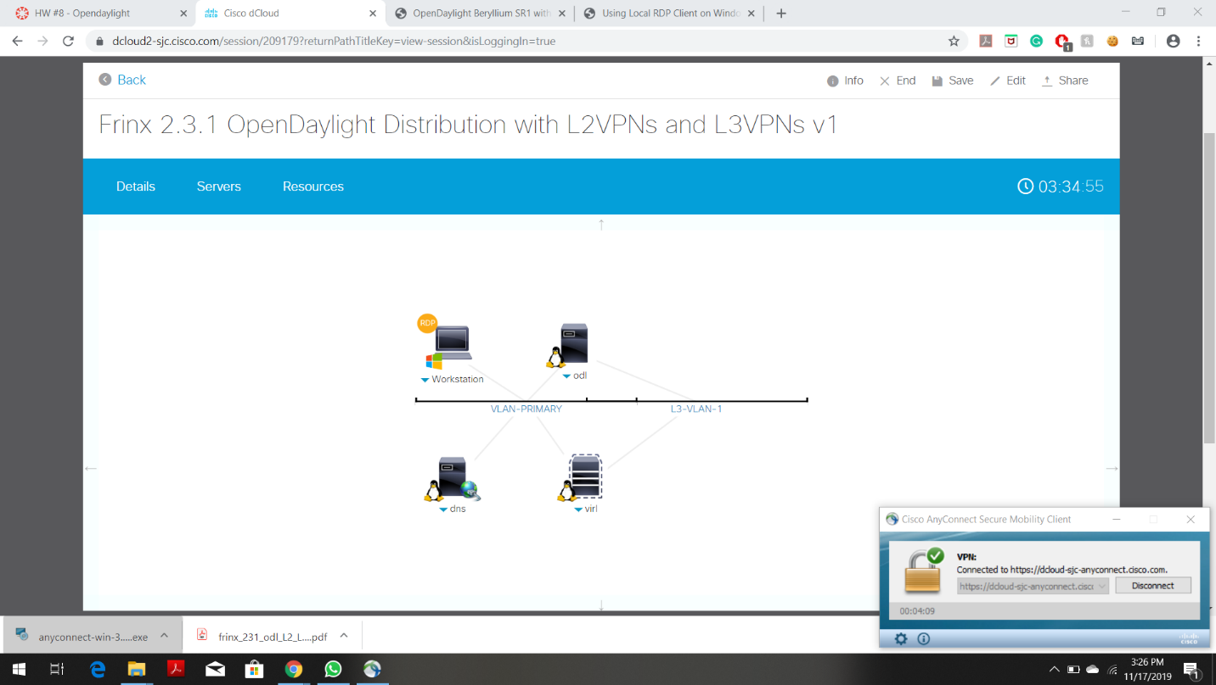

**SCENARIO - 1**

**Workstation desktop (Through remote desktop connection):**



**SSH connect to Karaf from the workstation desktop:**

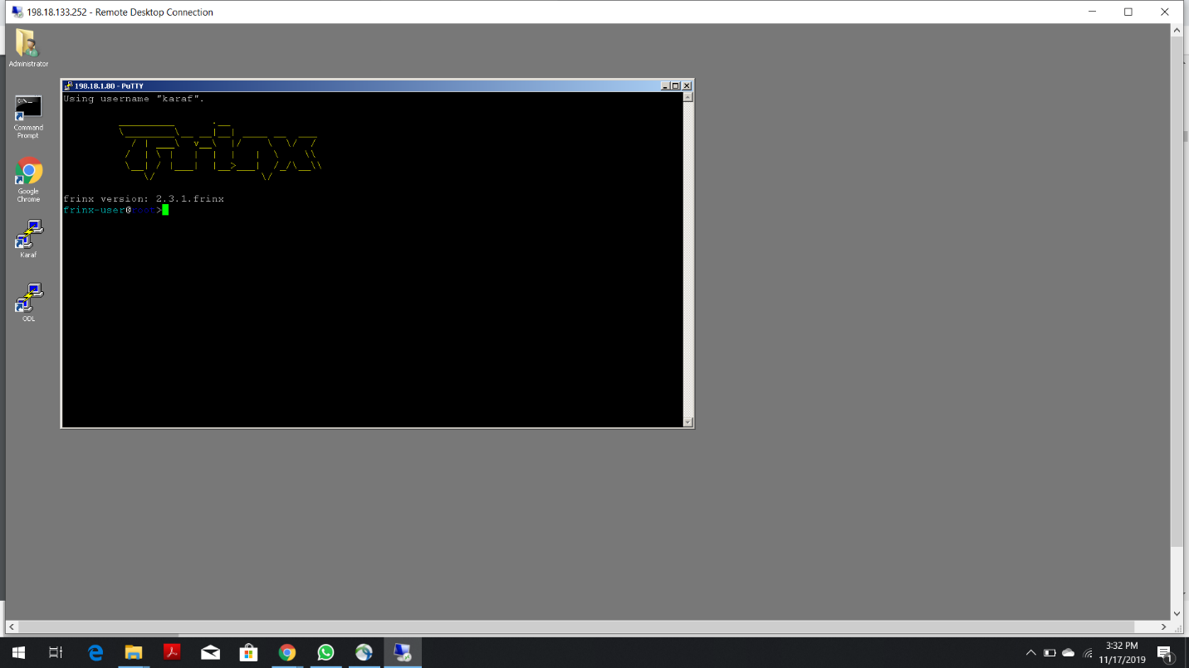

**Entering Command:** feature:install frinx-l3vpn **to Enable L3VPN feature from Karaf**

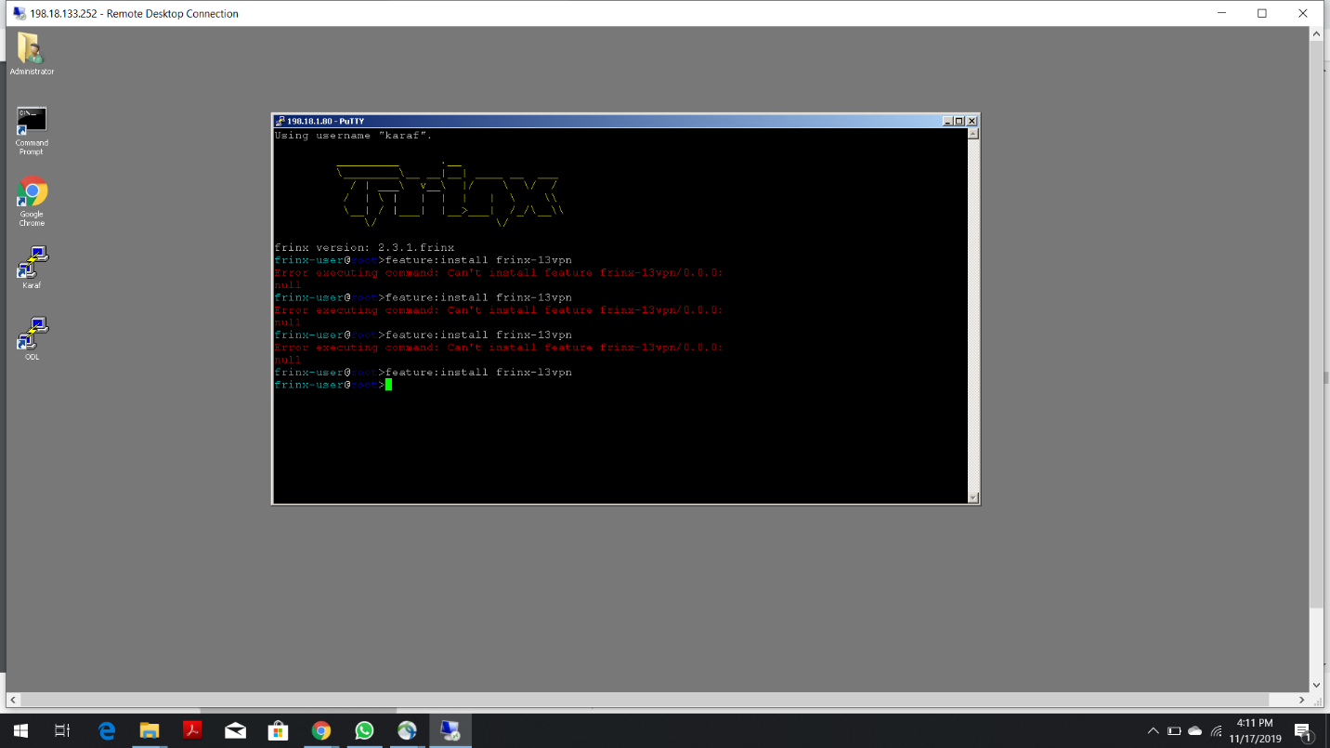

**From Postman sending I3vpn-provider-edge-topology OPER (Notice Empty topology):**

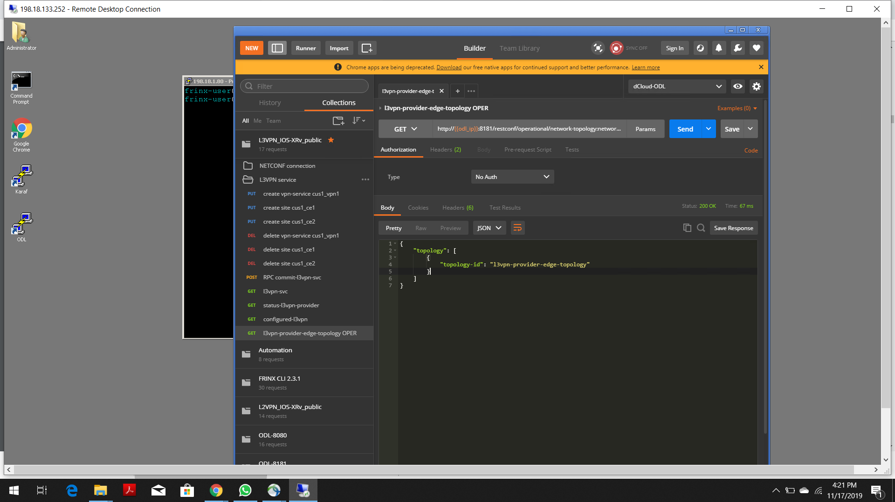

**Entering Command:** feature:install frinx-l3vpn-iosxrv **to install the XRv NEP:**

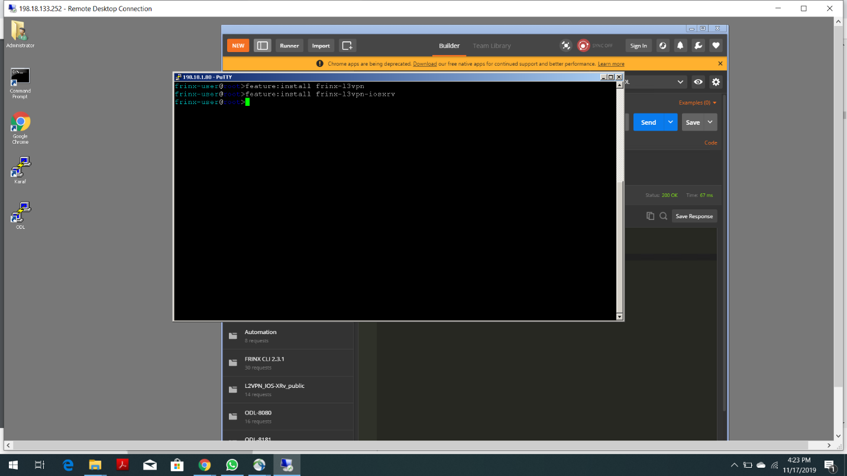

**From Postman again sending I3vpn-provider-edge-topology OPER (Notice PE and P routers from the topology):**

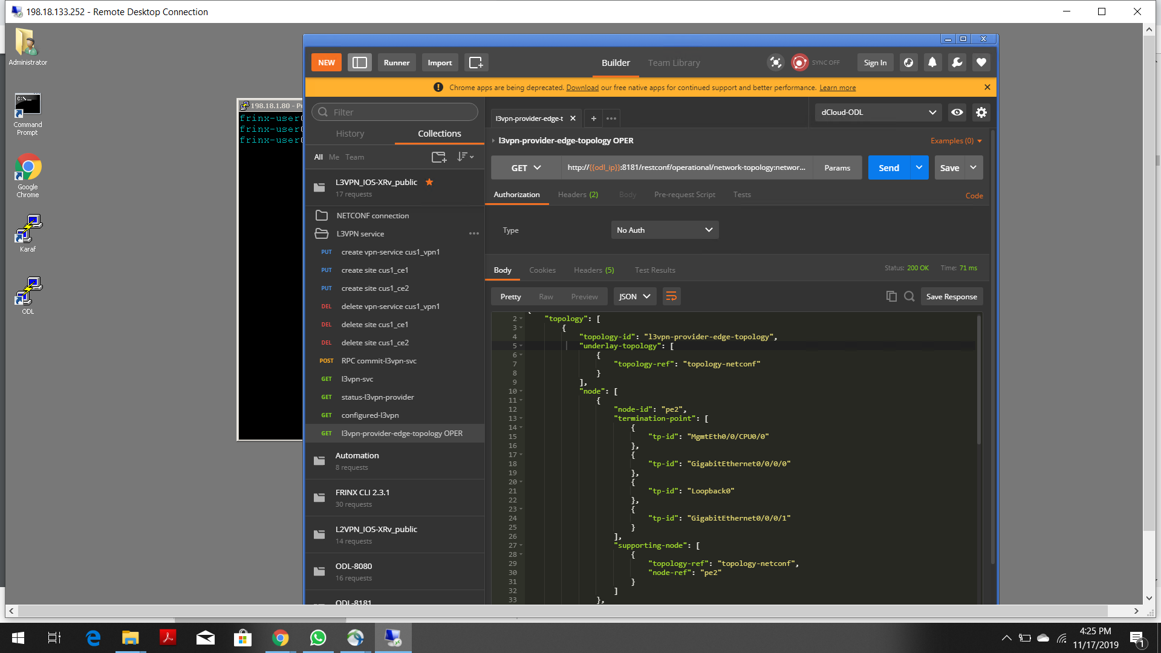

**SCENARIO 2:**

**From Postman sending “create vpn-service cus1_vpn1” (Status 201 created):**

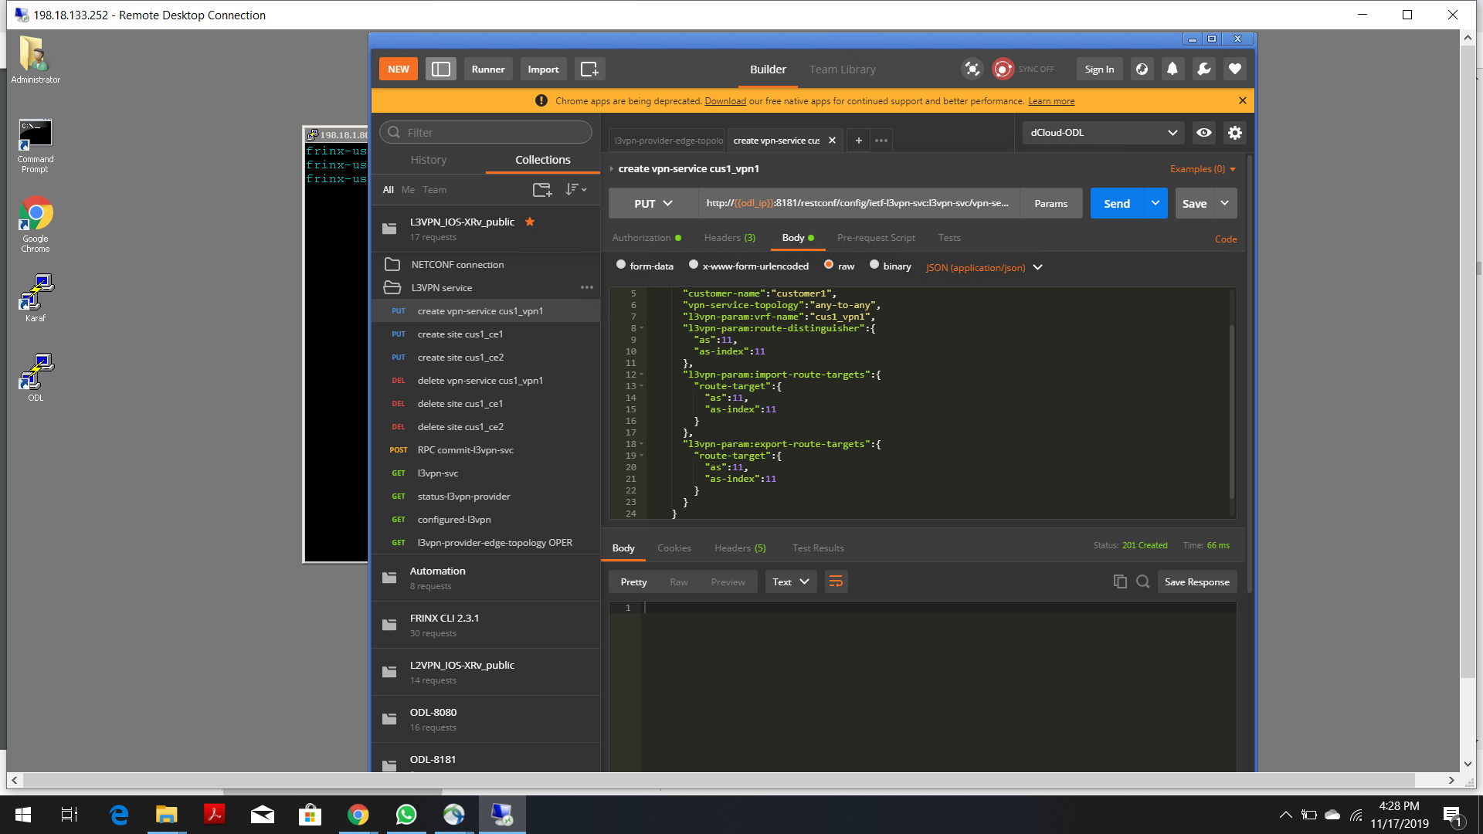

**From postman sending “create site cus1_ce1” , after modifying the payload body: (Status 201 created)**

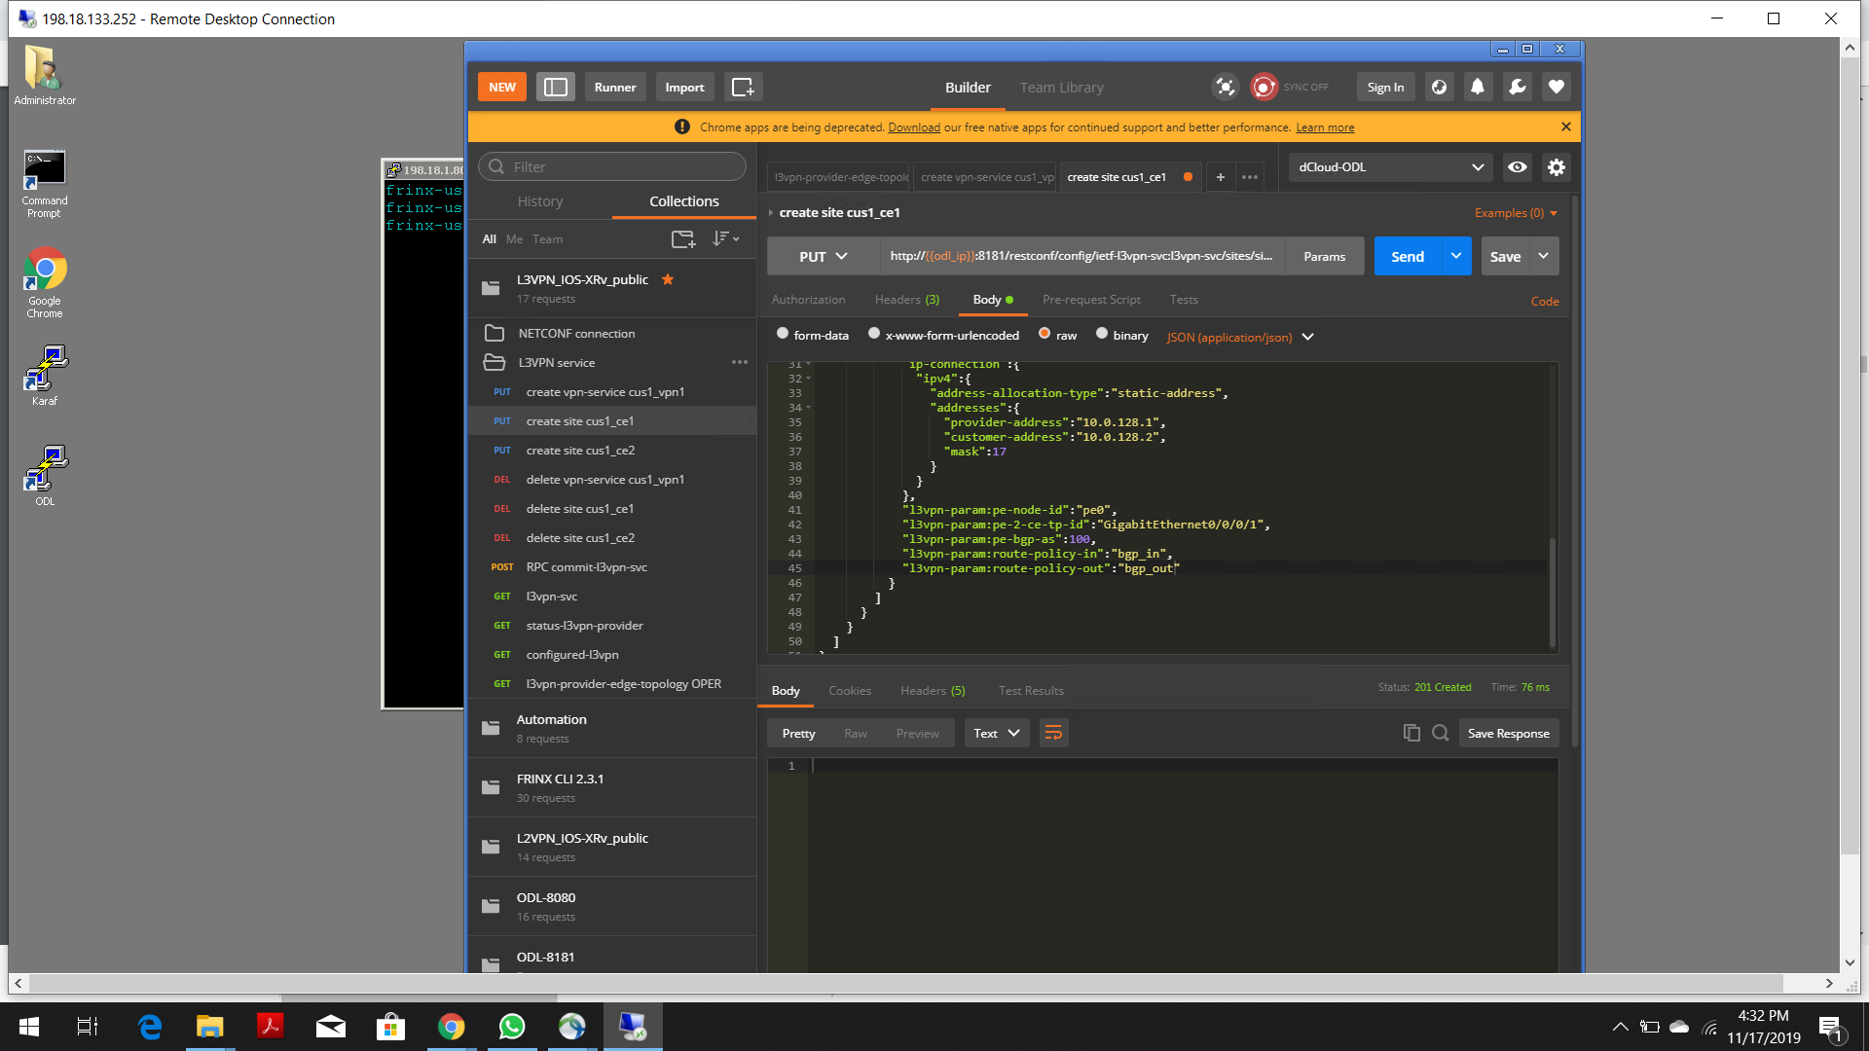

**From postman sending “RPC commit-I3vp-svc” (Status 200 OK and l3vpn-svc-version: is incremented after every attempt):**

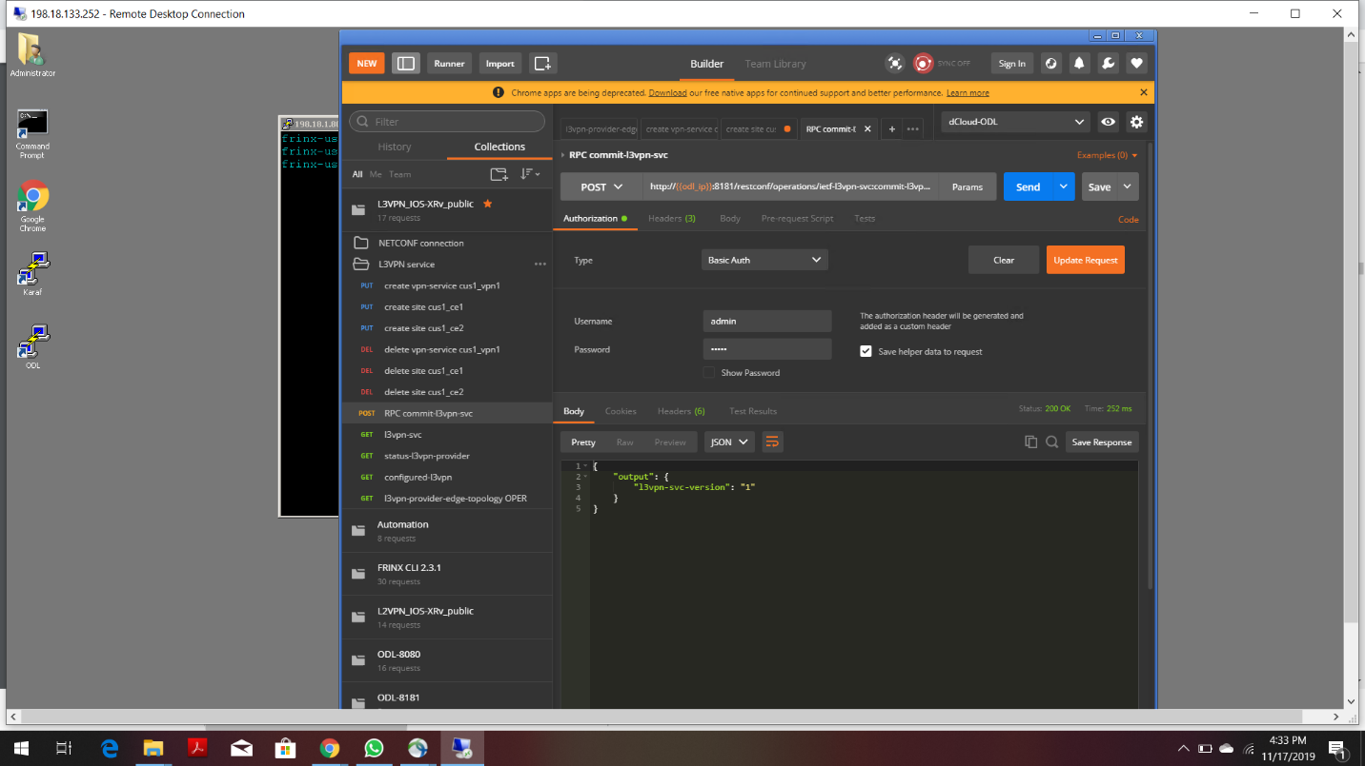

**From Postman Sending “status-I3vpn-provider” (Status is complete):**

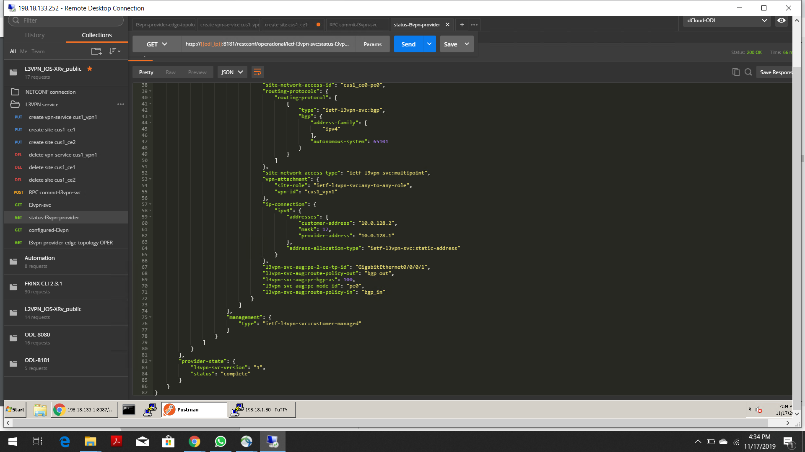

**SCENARIO 3**

**Live Visualization Engine:**

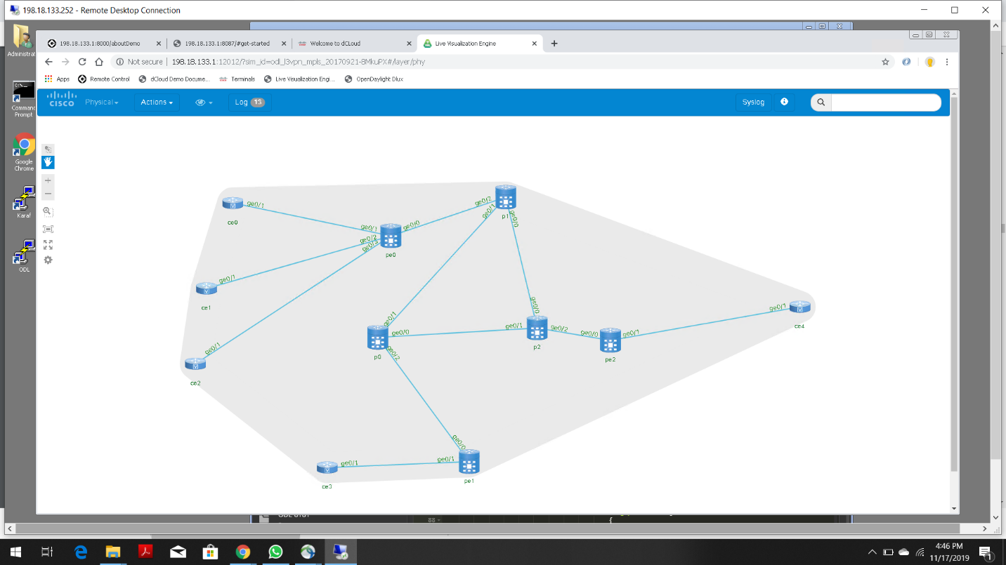

**Running command “show config rollback changes last 1 diff” on pe0 terminal:**

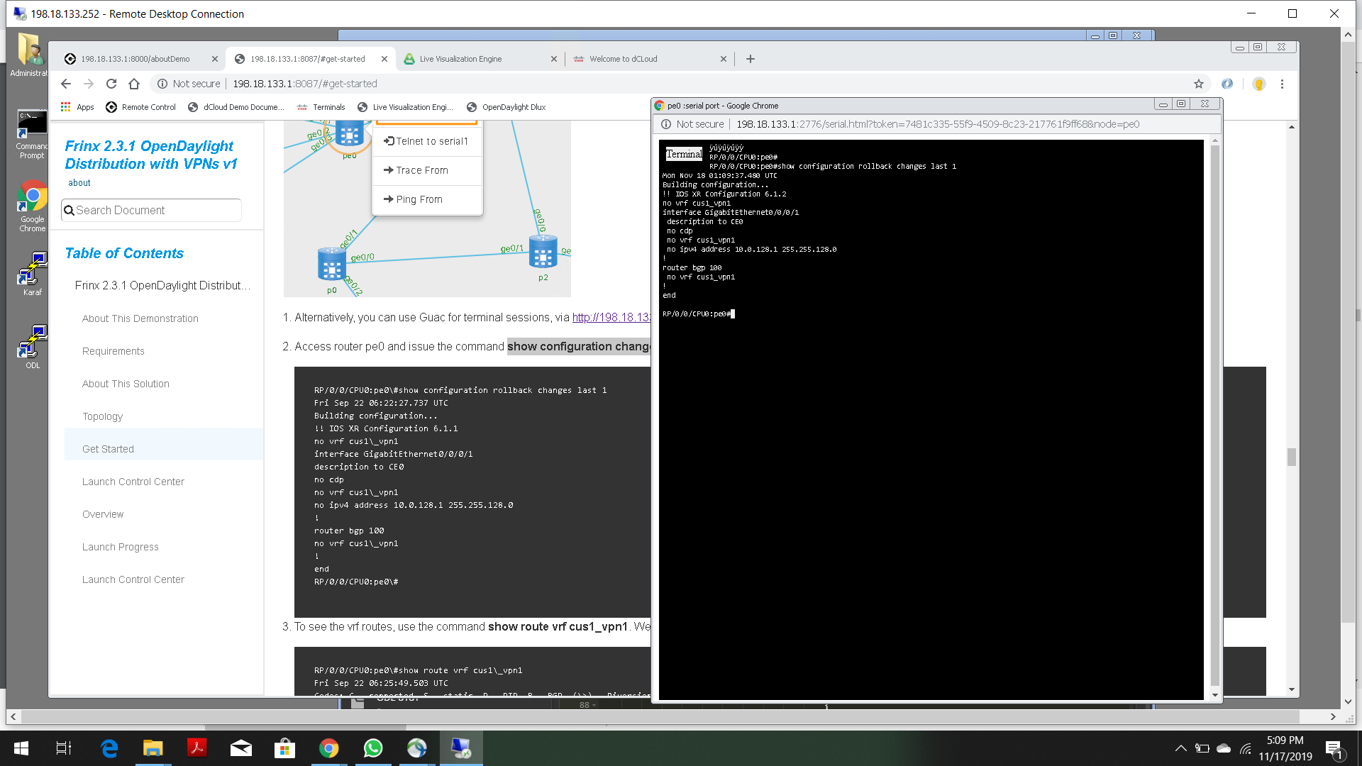

**Running command “show route vrf cus1_vpn1” on pe0 terminal:**

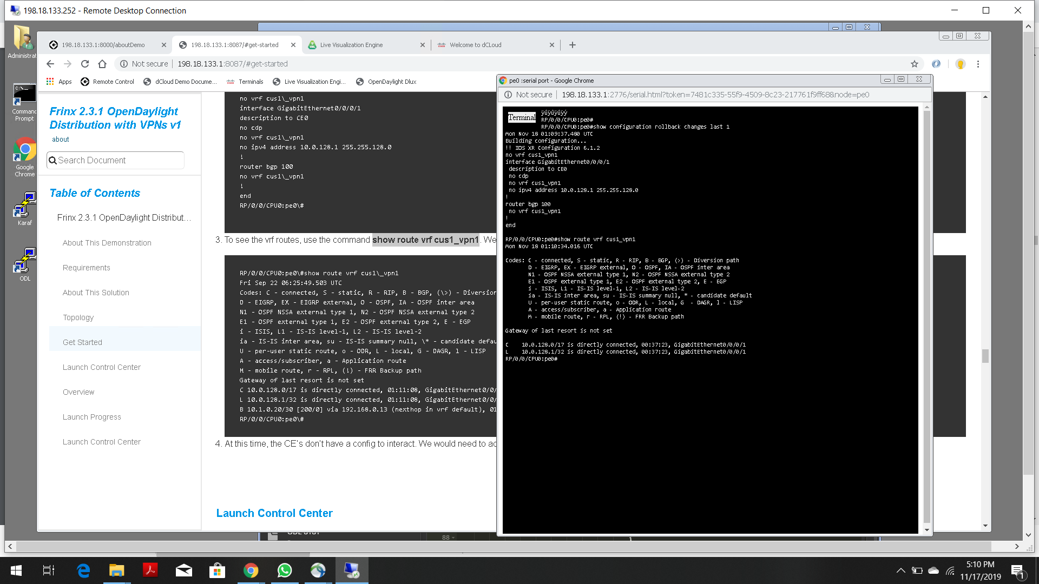

**Enabling ce0 terminal:**

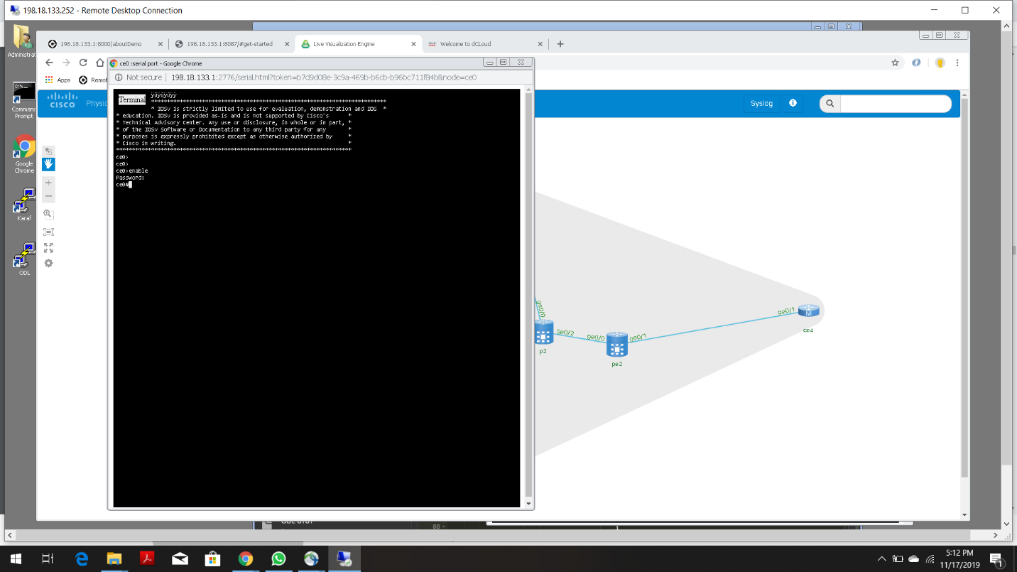

**SCENARIO 4**

**Entering Command:** feature:install frinx-l2vpn **to Enable L2VPN feature from Karaf**

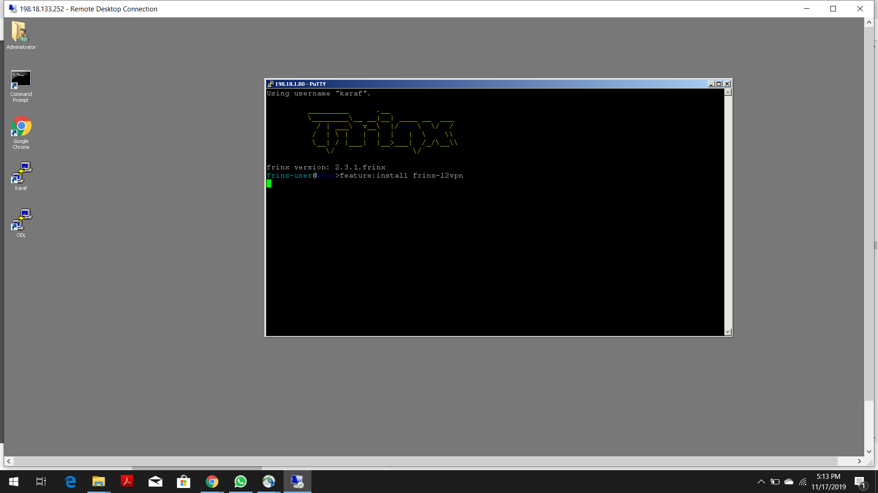

**From Postman sending I2vpn-provider-edge-topology OPER (Notice Empty topology):**

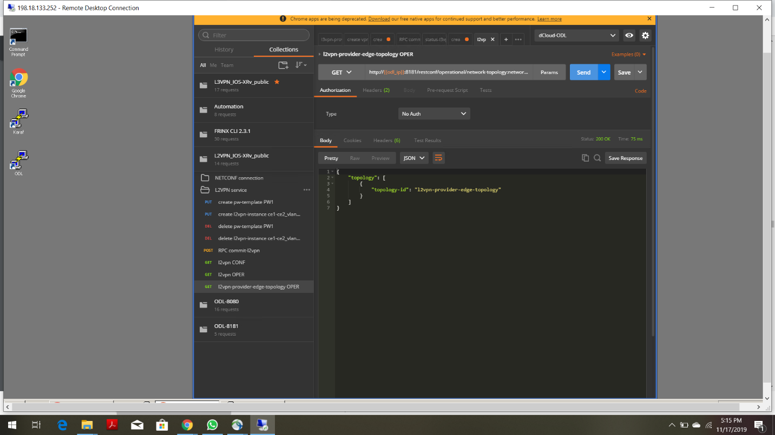

**Entering Command “**feature:install frinx-l2vpn-iosxrv” **to install the XRv NEP:**

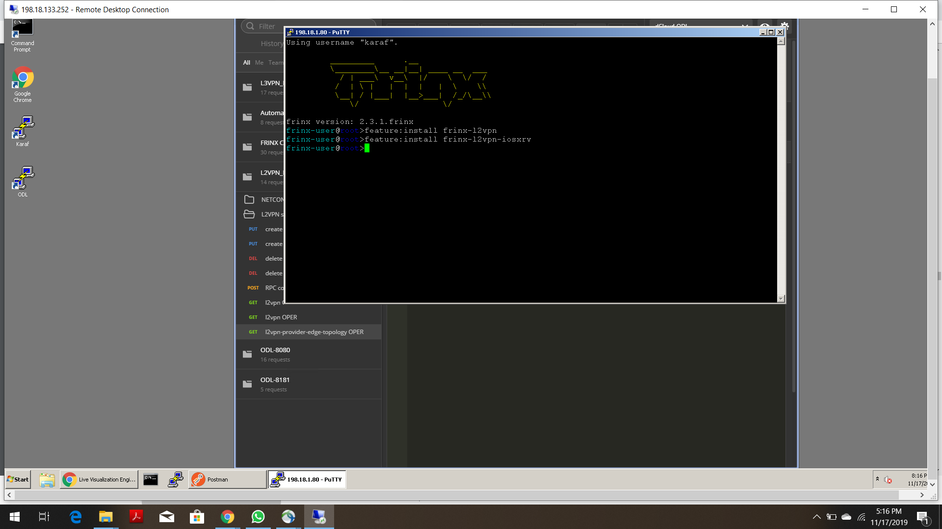

**From Postman again sending I2vpn-provider-edge-topology OPER (Notice PE and P routers from the topology):**

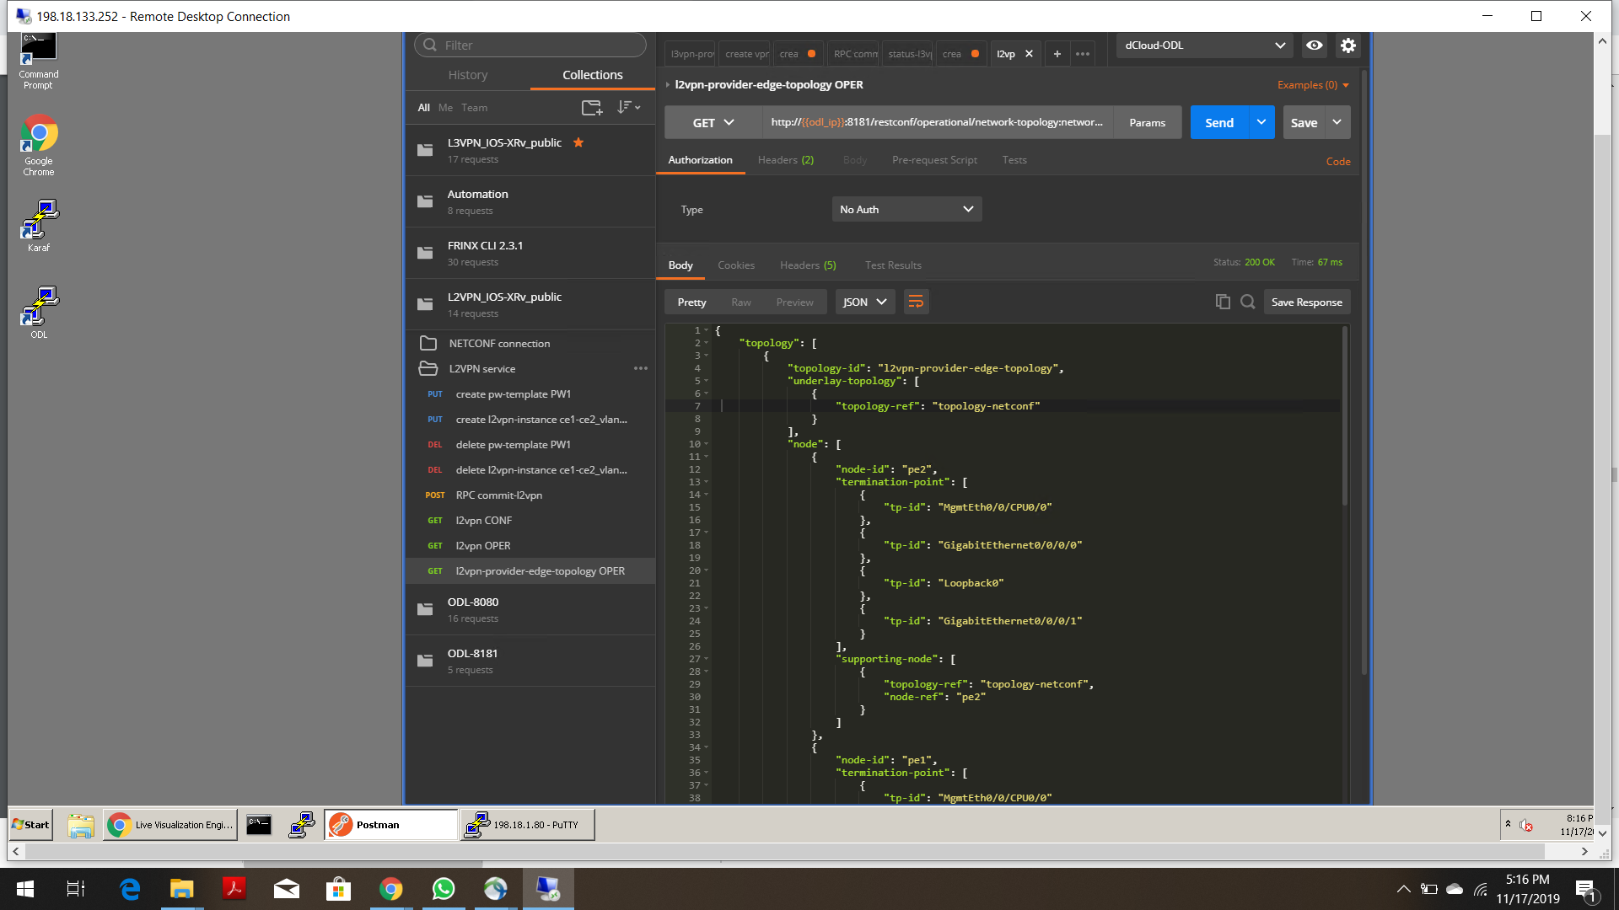

**SCENARIO 5**

**From Postman sending “create-pw-template PW1” (Status 201 created):**

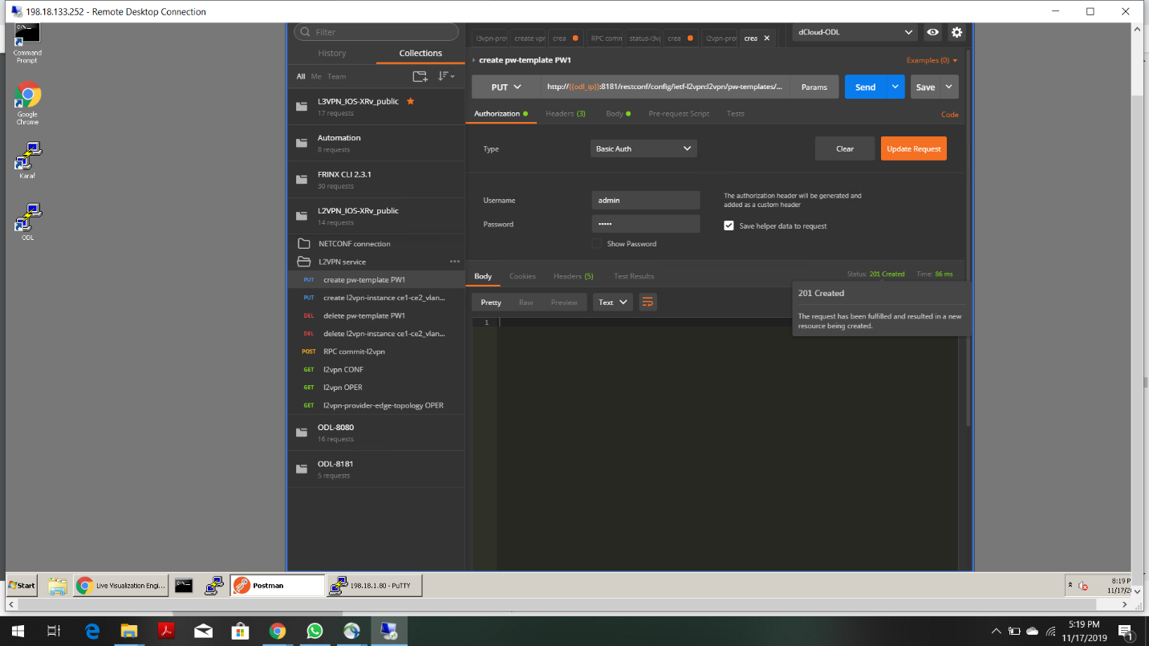

**From postman sending “create I2vpn-instance ce1-ce2_vlan3001”, after modifying the payload body: (Status 201 created)**

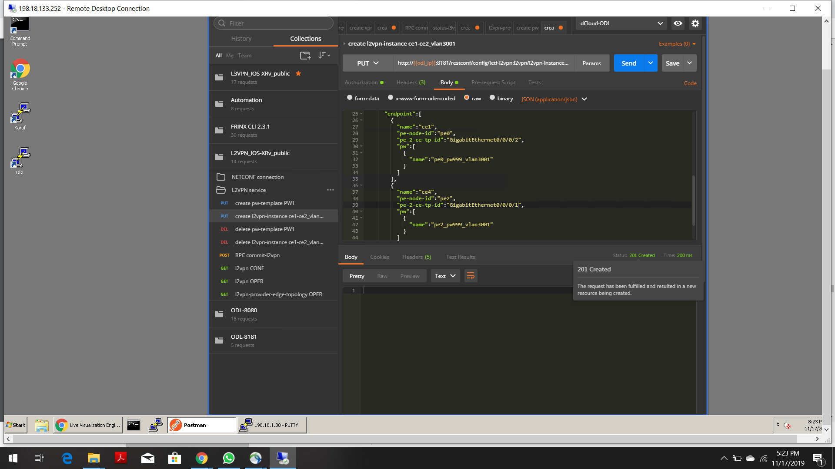

**From postman sending “RPC commit-I2vpn” (Confirm status is complete):**

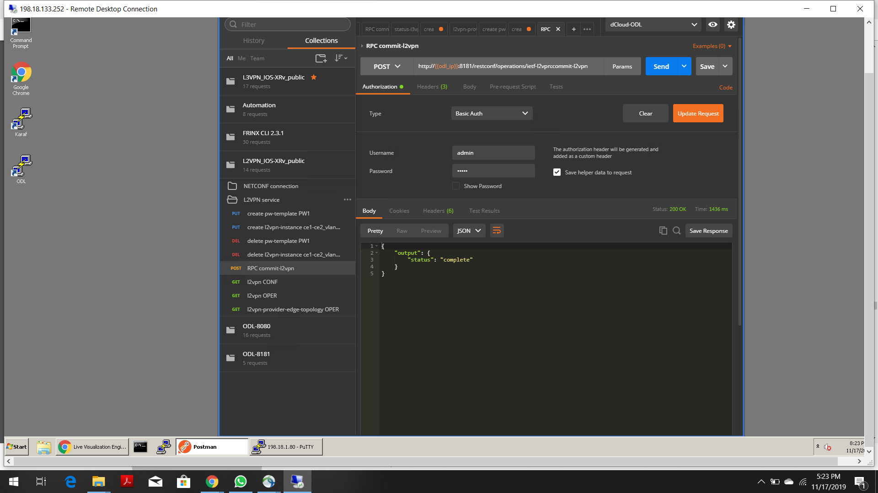

**From Postman Sending “L2VPN OPER” (L2VPN is active):**

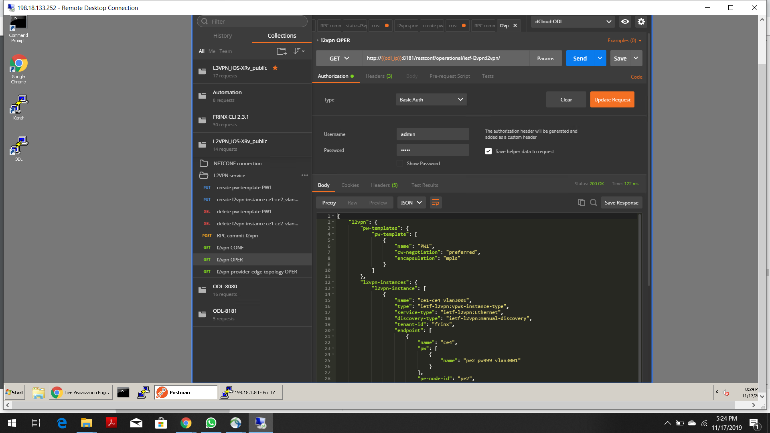

**SCENARIO-6**

**Running command “show config rollback changes last 1 diff” on pe2 terminal:**

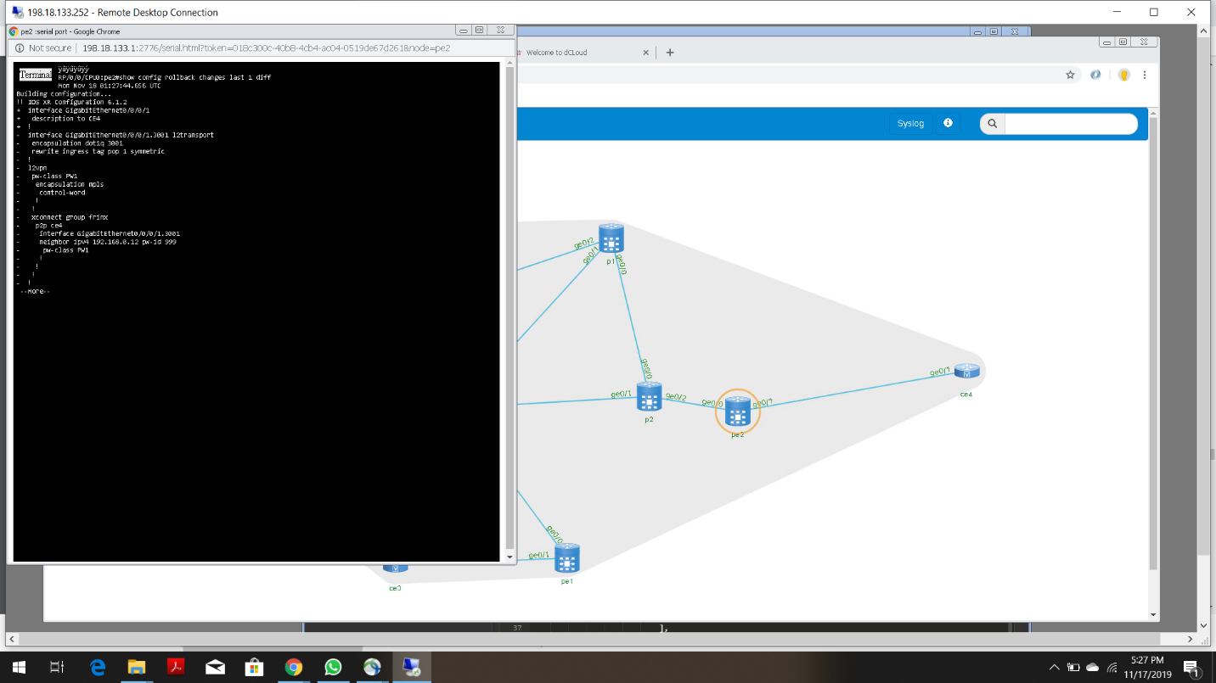

**Running command “show running l2vpn” on pe0 terminal (to verify L2VPN configuration):**

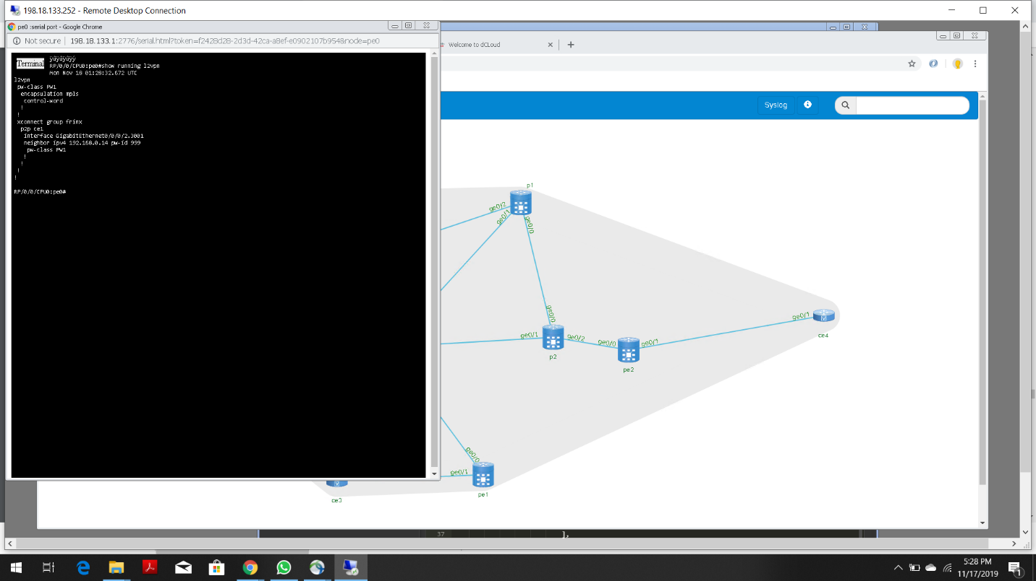

**Running command “show l2vpn xcon” on pe2 terminal (to verify that the PW is established):**

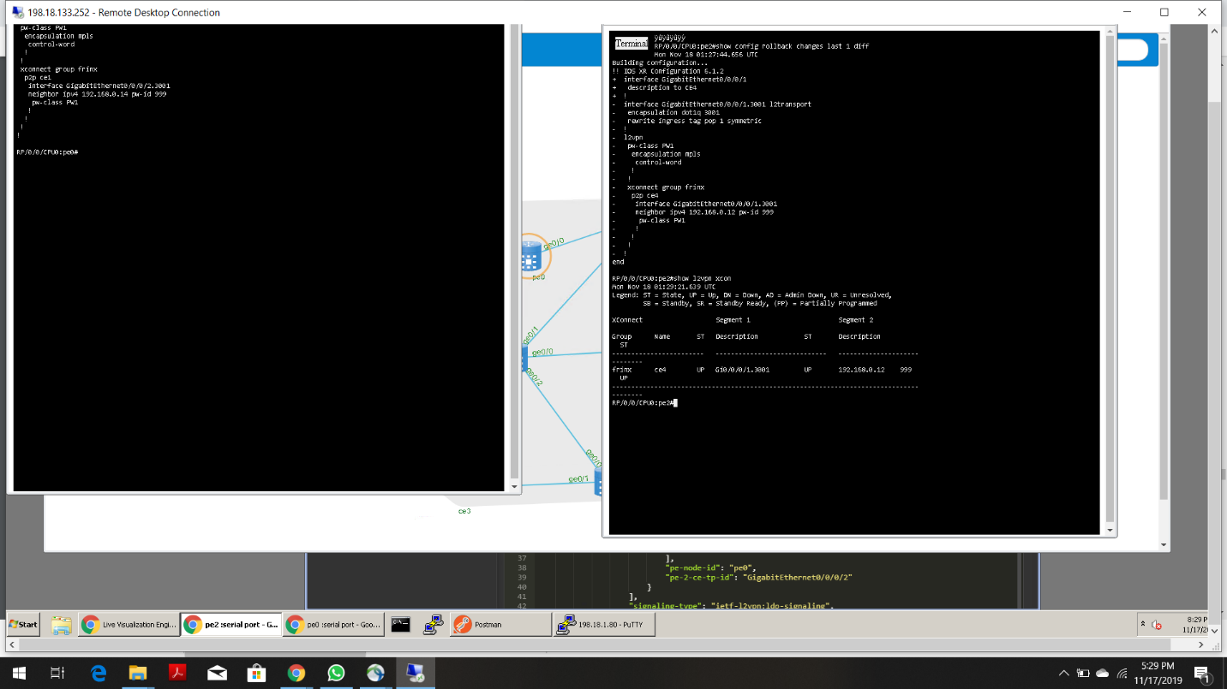

**Running same command “show l2vpn xcon” on pe0 terminal (We get the same result):**

